DESIGN DOCUMENT
AI CREATIVE MANAGEMENT SYSTEM
Field | Detail
Document Title | Flowchart Document — AI Digital Marketing Automation Platform
Document Version | 1.0
Document Status | Draft for Revie
Companion Documents | SRS v1.0 · Product Development Plan v1.0 · Software Design Document v1.0
Contents | 13 flowcharts covering every business process and state machine in the product
Prepared For | Product Development Team
Audience | Developers, QA, Product Owner, and the client during walkthroughs

1. About this Document
This document collects every process flow and state machine defined for the AI Digital Marketing Automation Platform into one place, drawn as flowcharts rather than described in prose.
It is a companion to the Software Design Document, not a replacement for it. The SDD explains why each step exists and what data it touches; this document shows the sequence and the decision points at a glance. It is intended for three uses: walking a client through how the product will behave, briefing a developer before they build a module, and giving QA the decision branches that need test coverage.
Every flowchart carries a reference to the requirement identifiers in the SRS and the section of the SDD that specifies it, so any box on any chart can be traced back to a written requirement.

1.1 Symbol Legend
The same visual convention is used on every chart.
Symbol | Meaning
Dark blue rounded box | Start or end point of the flow
Light blue rounded box | A process step performed by the system or a user
Amber diamond | A decision point; every outgoing arrow is labelled with its condition
Green box | A successful or committed outcome
Red box | A failure, blocked path, or exception route
Purple 3D box | A call to an external service — AI provider, social platform, WhatsApp or email
Cylinder | A database or storage write
Teal box | A queued or scheduled background operation
Dashed arrow | A data dependency rather than a sequential step

1.2 Index of Flowcharts
ID | Flowchart | Traces to
F-01 | Master System Flow | SRS §10 · SDD §8
F-02 | Authentication and Login Flow | FR-ADM-001, FR-CLT-002 · SDD §5.1
F-03 | Company Onboarding Flow | SRS §10.1, FR-CMP-001, FR-BRD-001, FR-CLT-001 · SDD §8.1
F-04 | Content Calendar Excel Import Flow | FR-CAL-002, FR-CAL-003 · SDD §5.5
F-05 | AI Creative Generation Flow | SRS §10.3, FR-AI-001 to FR-AI-008 · SDD §5.6, §9
F-06 | AI Video Generation Flow | FR-VID-001 to FR-VID-006 · SDD §5.7
F-07 | Client Approval and Regeneration Flow | SRS §10.4, FR-APR-001 to FR-APR-005 · SDD §5.8
F-08 | Publishing Flow with Retry Handling | SRS §10.5, FR-PUB-001 to FR-PUB-005 · SDD §5.9
F-09 | Social Account Connection and Token Lifecycle | FR-SOC-001 to FR-SOC-003, FR-SOC-006 · SDD §5.10, §10.3
F-10 | Notification Dispatch Flow | FR-NOT-001 to FR-NOT-005, FR-WA-003 to FR-WA-008 · SDD §5.11, §5.12
F-11 | Analytics Collection and Reporting Flow | SRS §10.6, FR-ANL-001 to FR-ANL-007, FR-REP-001 to FR-REP-005 · SDD §5.13, §5.14
F-12 | Subscription Lifecycle (State Diagram) | SRS §26 · SDD §5.15
F-13 | Content Item State Diagram | SDD §5.5, §5.8, §5.9

1.3 How the Flows Fit Together
F-01 is the master flow: it shows the seven phases the product moves through, and each remaining chart expands one of them. Read F-01 first, then read the detail chart for whichever phase you are working on.
Phase in F-01 | Detail flowcharts
1. Company onboarding | F-02 Authentication · F-03 Onboarding · F-09 Social account connection
2. Content planning | F-04 Calendar Excel import
3. AI generation | F-05 Creative generation · F-06 Video generation
4. Client approval | F-07 Approval and regeneration · F-10 Notification dispatch
5. Publishing | F-08 Publishing with retry
6. Analytics | F-11 Analytics collection
7. Reporting | F-11 Reporting (lower half)
Cross-cutting | F-12 Subscription lifecycle · F-13 Content item state diagram

1.4 Reading the Decision Points
Three decision points on these charts carry business rules that are easy to miss and are the most common source of defects:
- F-05 — "Variations passed?" has three outcomes, not two. Three of three is a normal ready state; one or two produces a partial set that is still shown to the client while the failed slots retry once; zero fails the calendar item and alerts the Admin.
- F-07 — "First rejection?" enforces the one-time regeneration rule. A second rejection must never trigger another AI round; it routes to Admin manual intervention.
- F-08 — "Error type?" determines whether a publishing failure is retried at all. Only transient errors are retried; authentication and permanent errors stop immediately so the system does not burn attempts against a dead token.

F-01 Master System Flow
Traces to: SRS §10 · SDD §8
End-to-end lifecycle of the platform, from company onboarding through to reporting. Every other flowchart in this document expands one phase of this diagram.
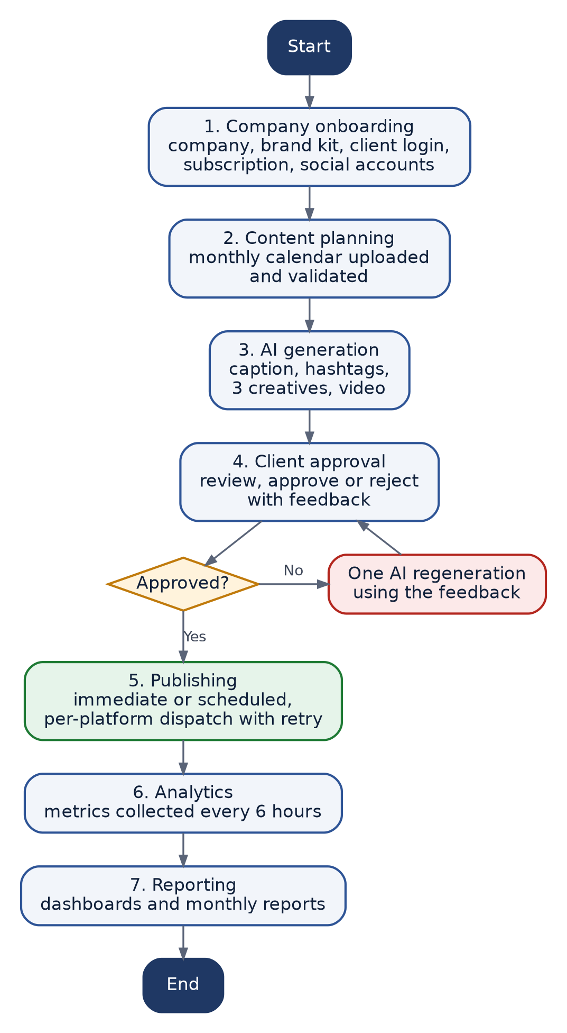
Figure F-01 — Master System Flow

F-02 Authentication and Login Flow
Traces to: FR-ADM-001, FR-CLT-002 · SDD §5.1
Credential verification, lockout handling, token issue and role-based landing. Both Admin and Client use the same flow; only the destination differs.
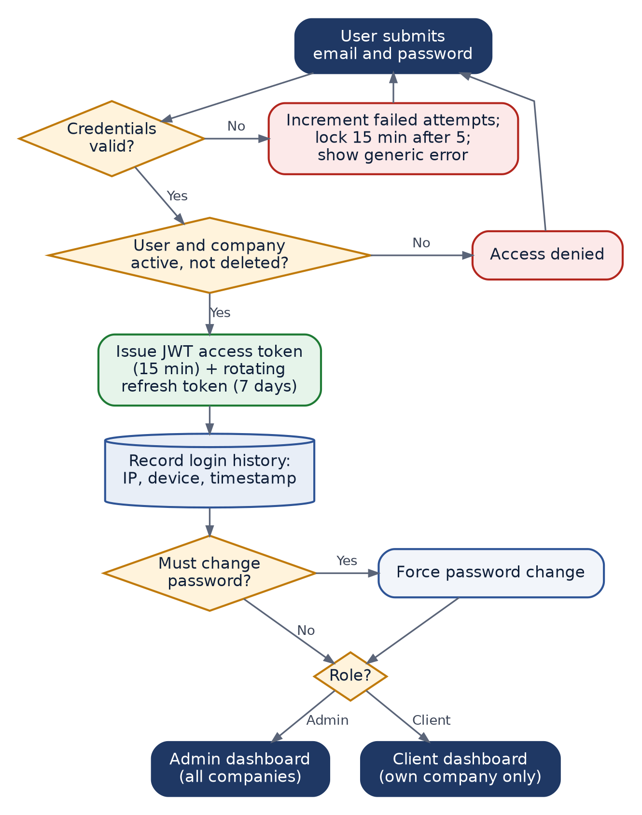
Figure F-02 — Authentication and Login Flow

F-03 Company Onboarding Flow
Traces to: SRS §10.1, FR-CMP-001, FR-BRD-001, FR-CLT-001 · SDD §8.1
Steps the Admin follows to take a new client company from creation to being ready for content planning. Two gates block progress: an incomplete brand kit blocks AI generation, and no connected social account blocks publishing.
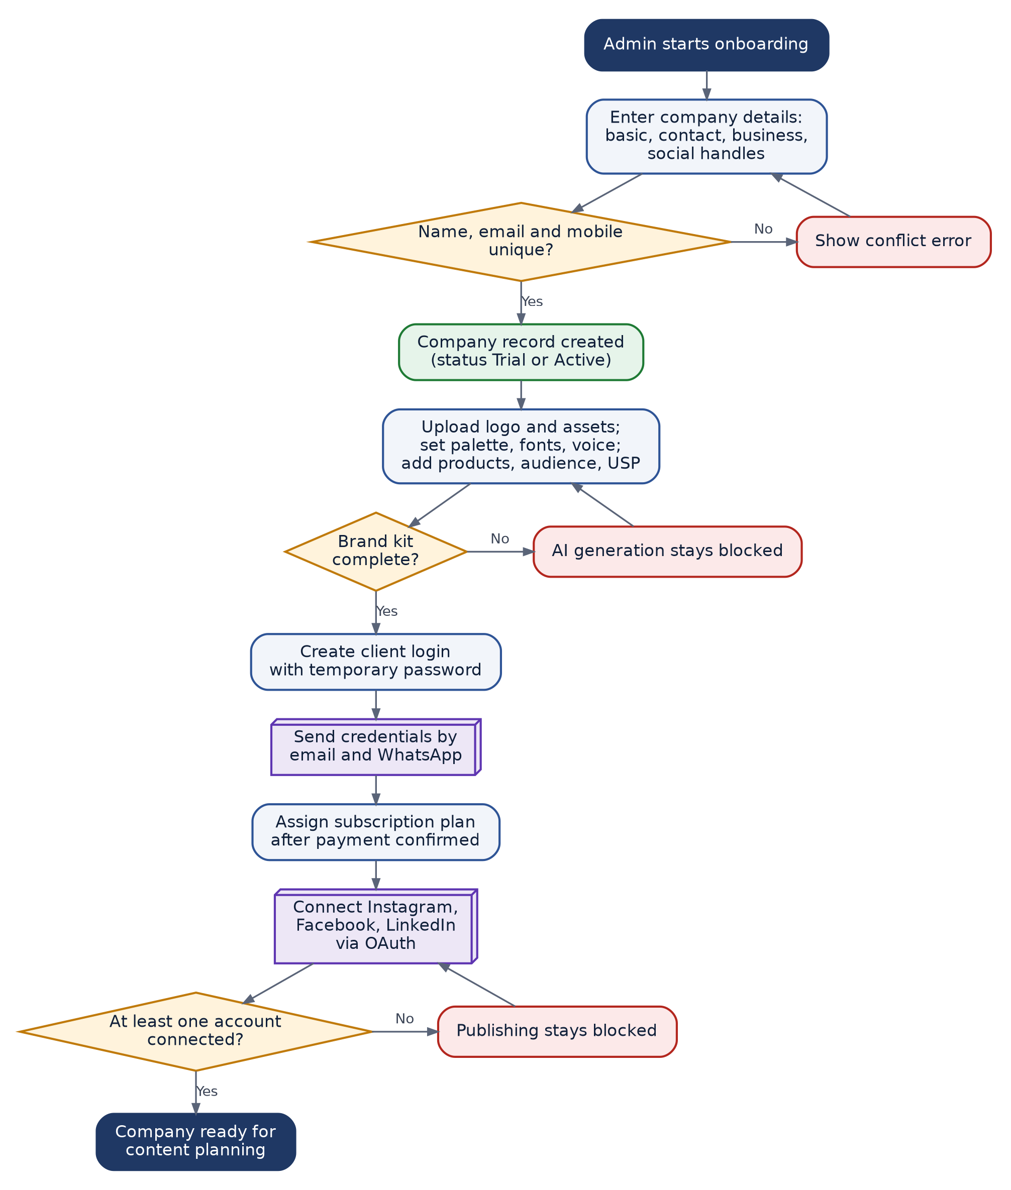
Figure F-03 — Company Onboarding Flow

F-04 Content Calendar Excel Import Flow
Traces to: FR-CAL-002, FR-CAL-003 · SDD §5.5
Two-phase import: parse and validate without writing, then commit only after the Admin reviews the row-level report. This prevents a partially imported month.
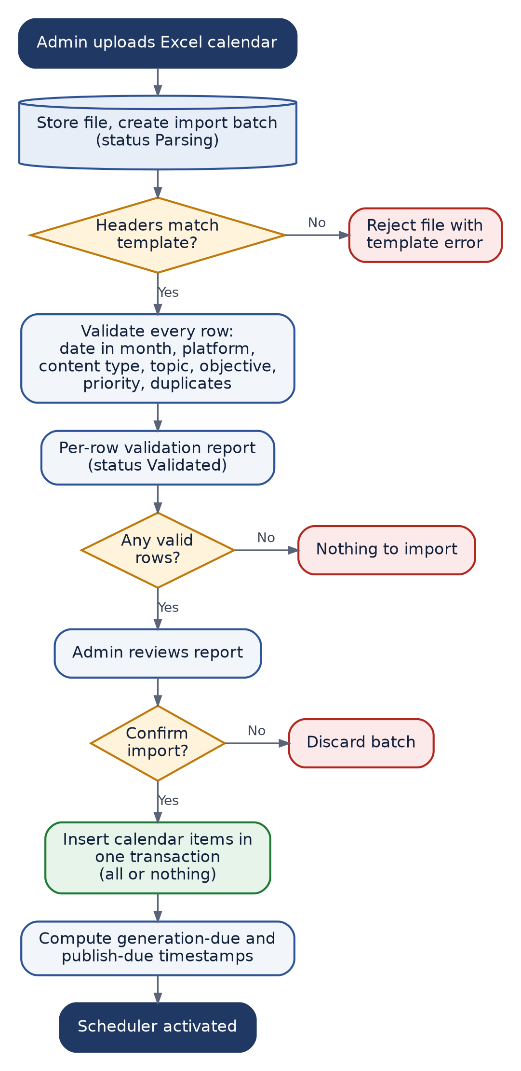
Figure F-04 — Content Calendar Excel Import Flow

F-05 AI Creative Generation Flow
Traces to: SRS §10.3, FR-AI-001 to FR-AI-008 · SDD §5.6, §9
How a calendar item becomes a caption, hashtag set and three creative variations. The generation group succeeds fully, partially or not at all, and each outcome is handled differently.
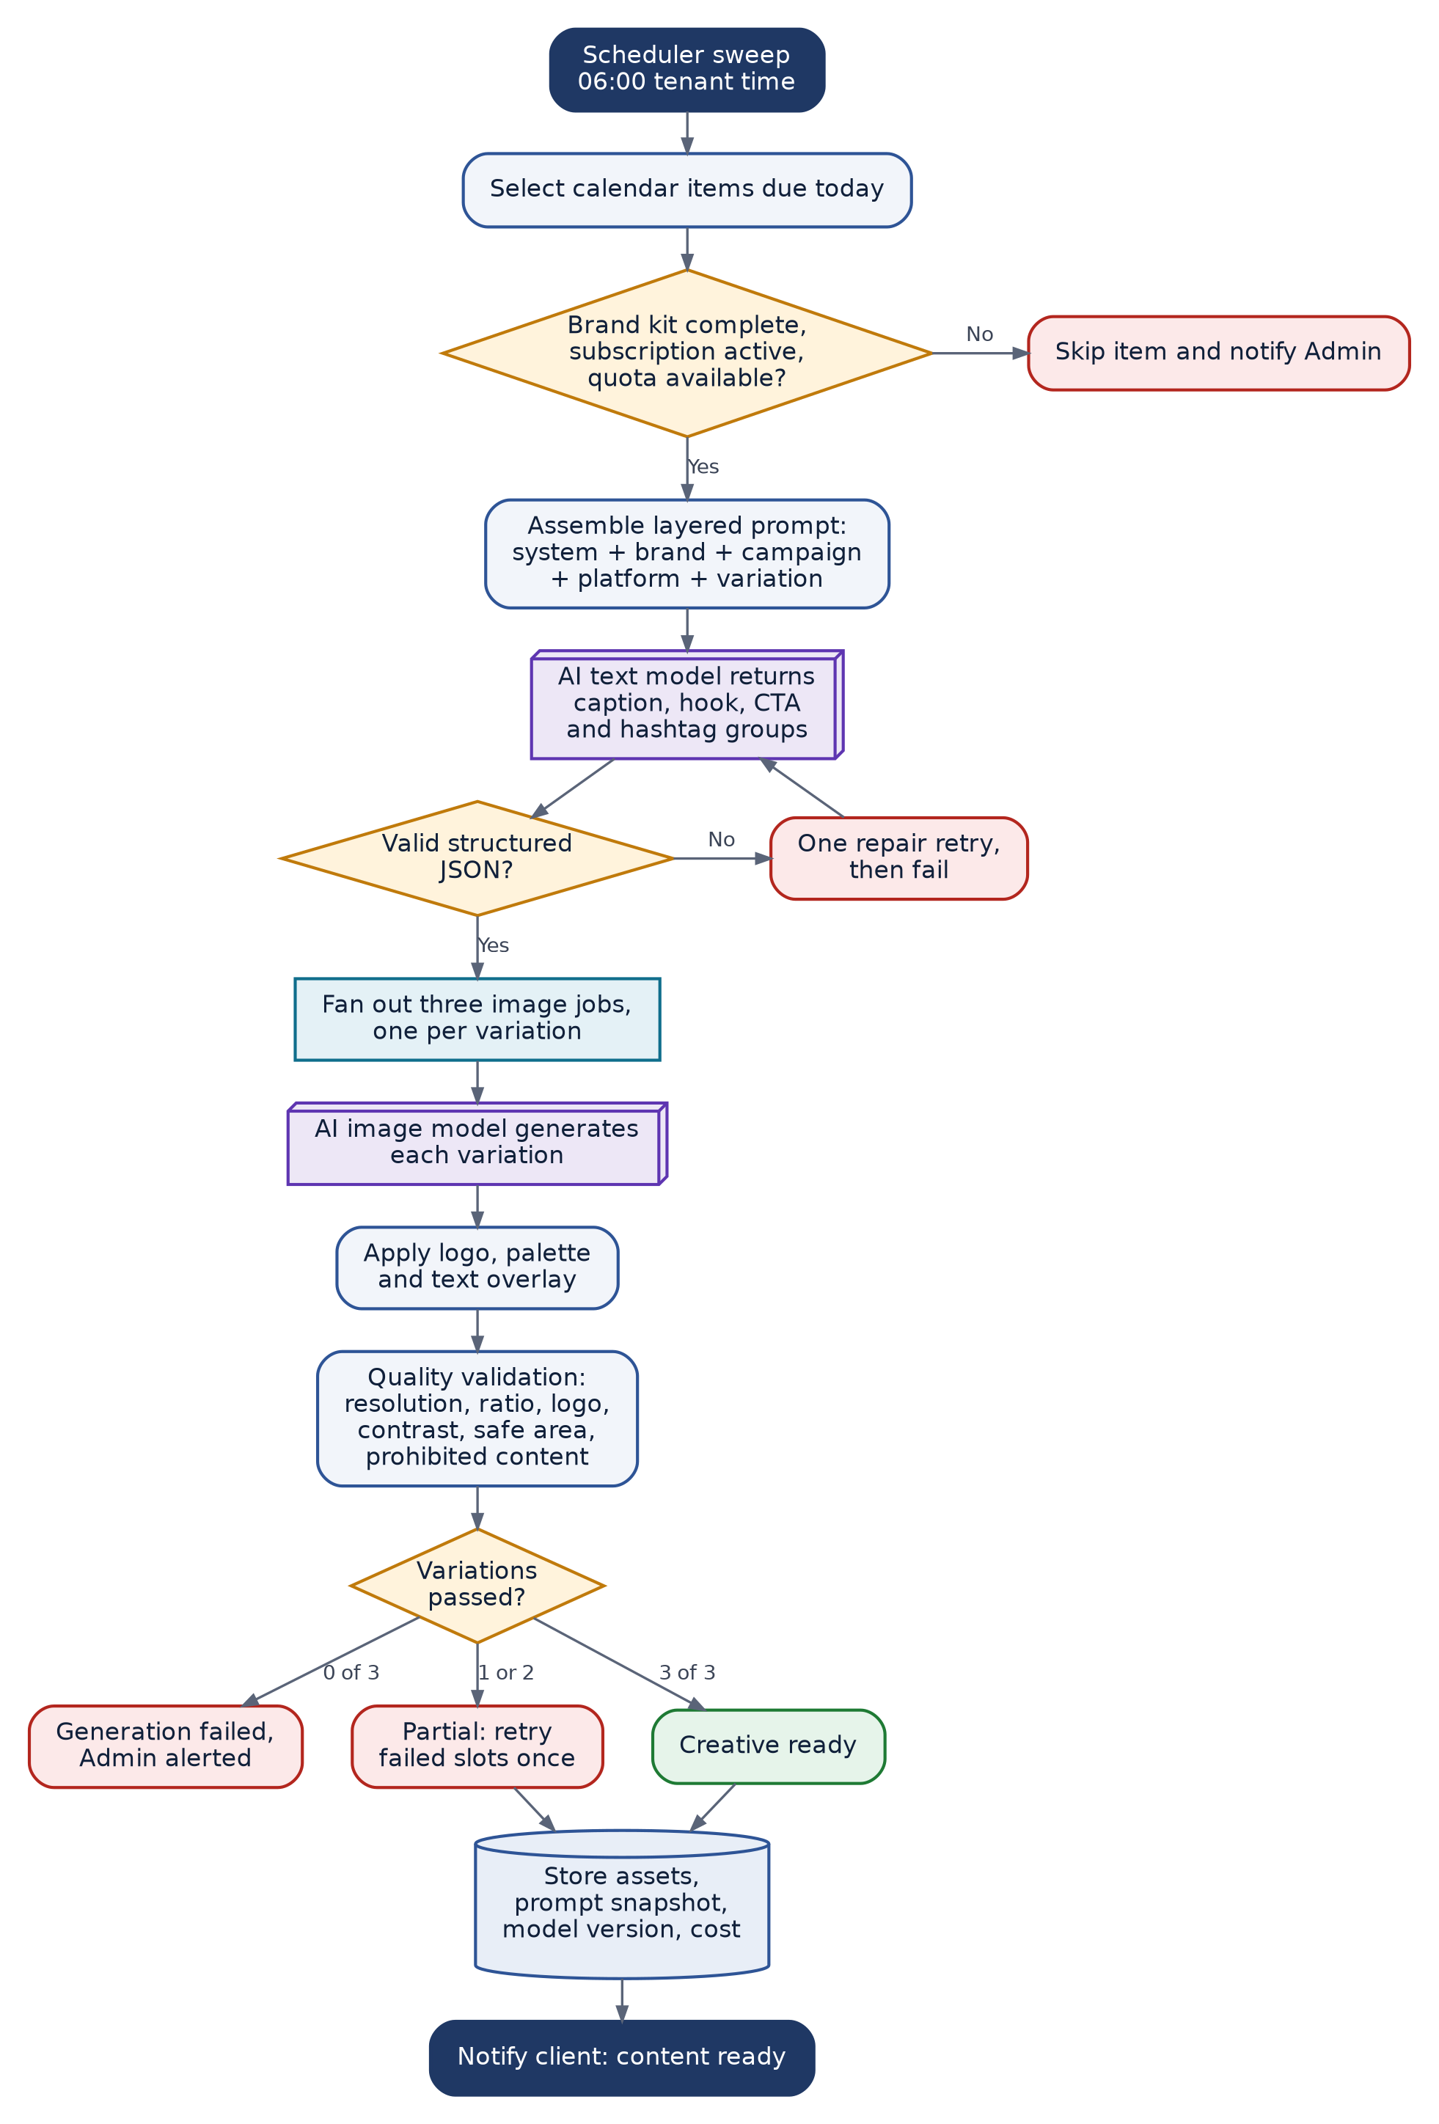
Figure F-05 — AI Creative Generation Flow

F-06 AI Video Generation Flow
Traces to: FR-VID-001 to FR-VID-006 · SDD §5.7
Script to finished short-form video. If the video provider is unavailable the system falls back to an animated composition of brand stills rather than failing the calendar item.
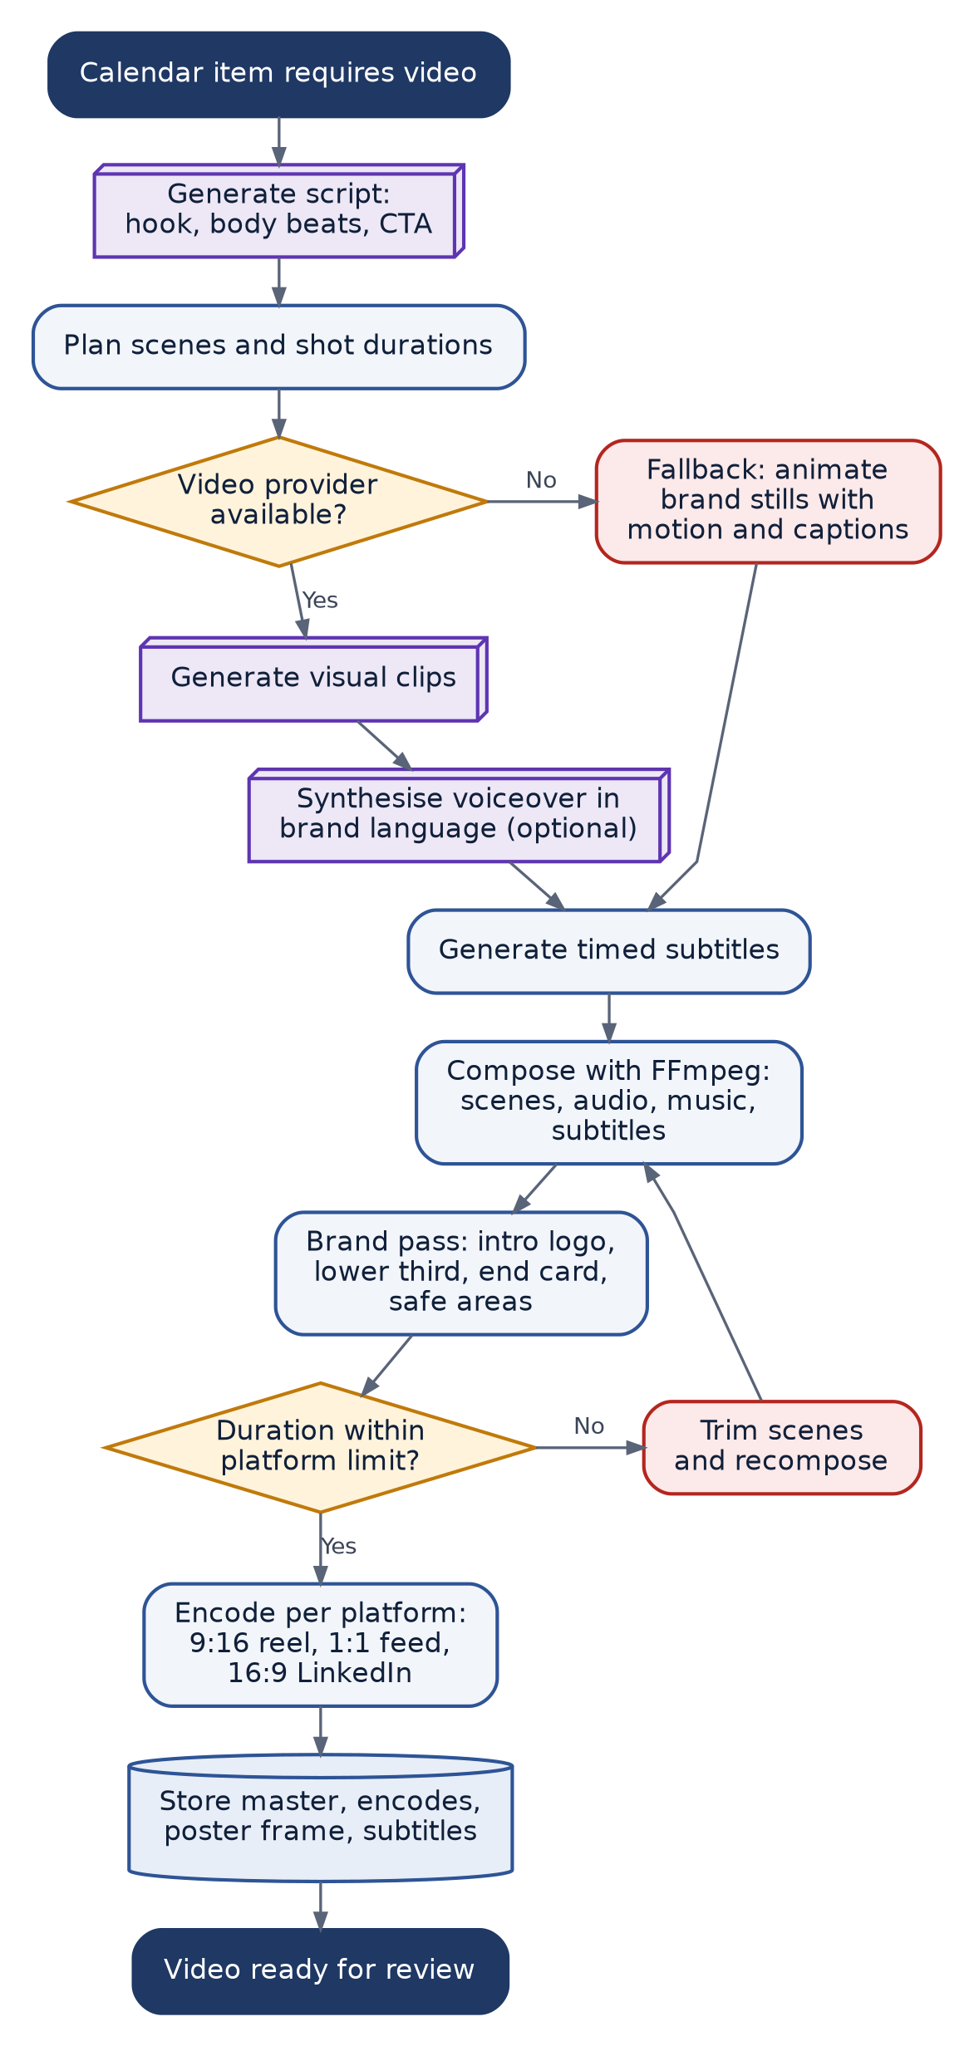
Figure F-06 — AI Video Generation Flow

F-07 Client Approval and Regeneration Flow
Traces to: SRS §10.4, FR-APR-001 to FR-APR-005 · SDD §5.8
The client review journey. Exactly one automatic regeneration is permitted; a second rejection routes the item to Admin manual intervention.
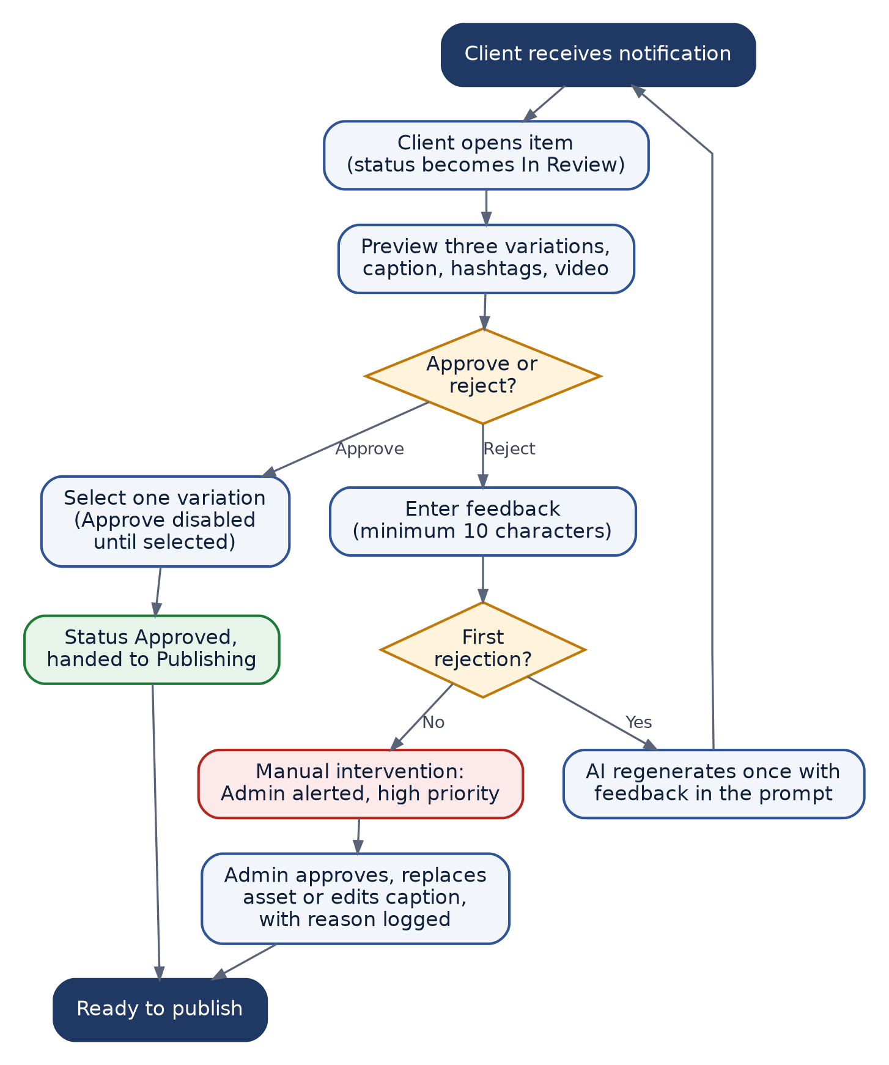
Figure F-07 — Client Approval and Regeneration Flow

F-08 Publishing Flow with Retry Handling
Traces to: SRS §10.5, FR-PUB-001 to FR-PUB-005 · SDD §5.9
Dispatch of approved content to each platform. Pre-flight checks catch problems before the platform is called, and errors are classified so that only transient failures are retried.
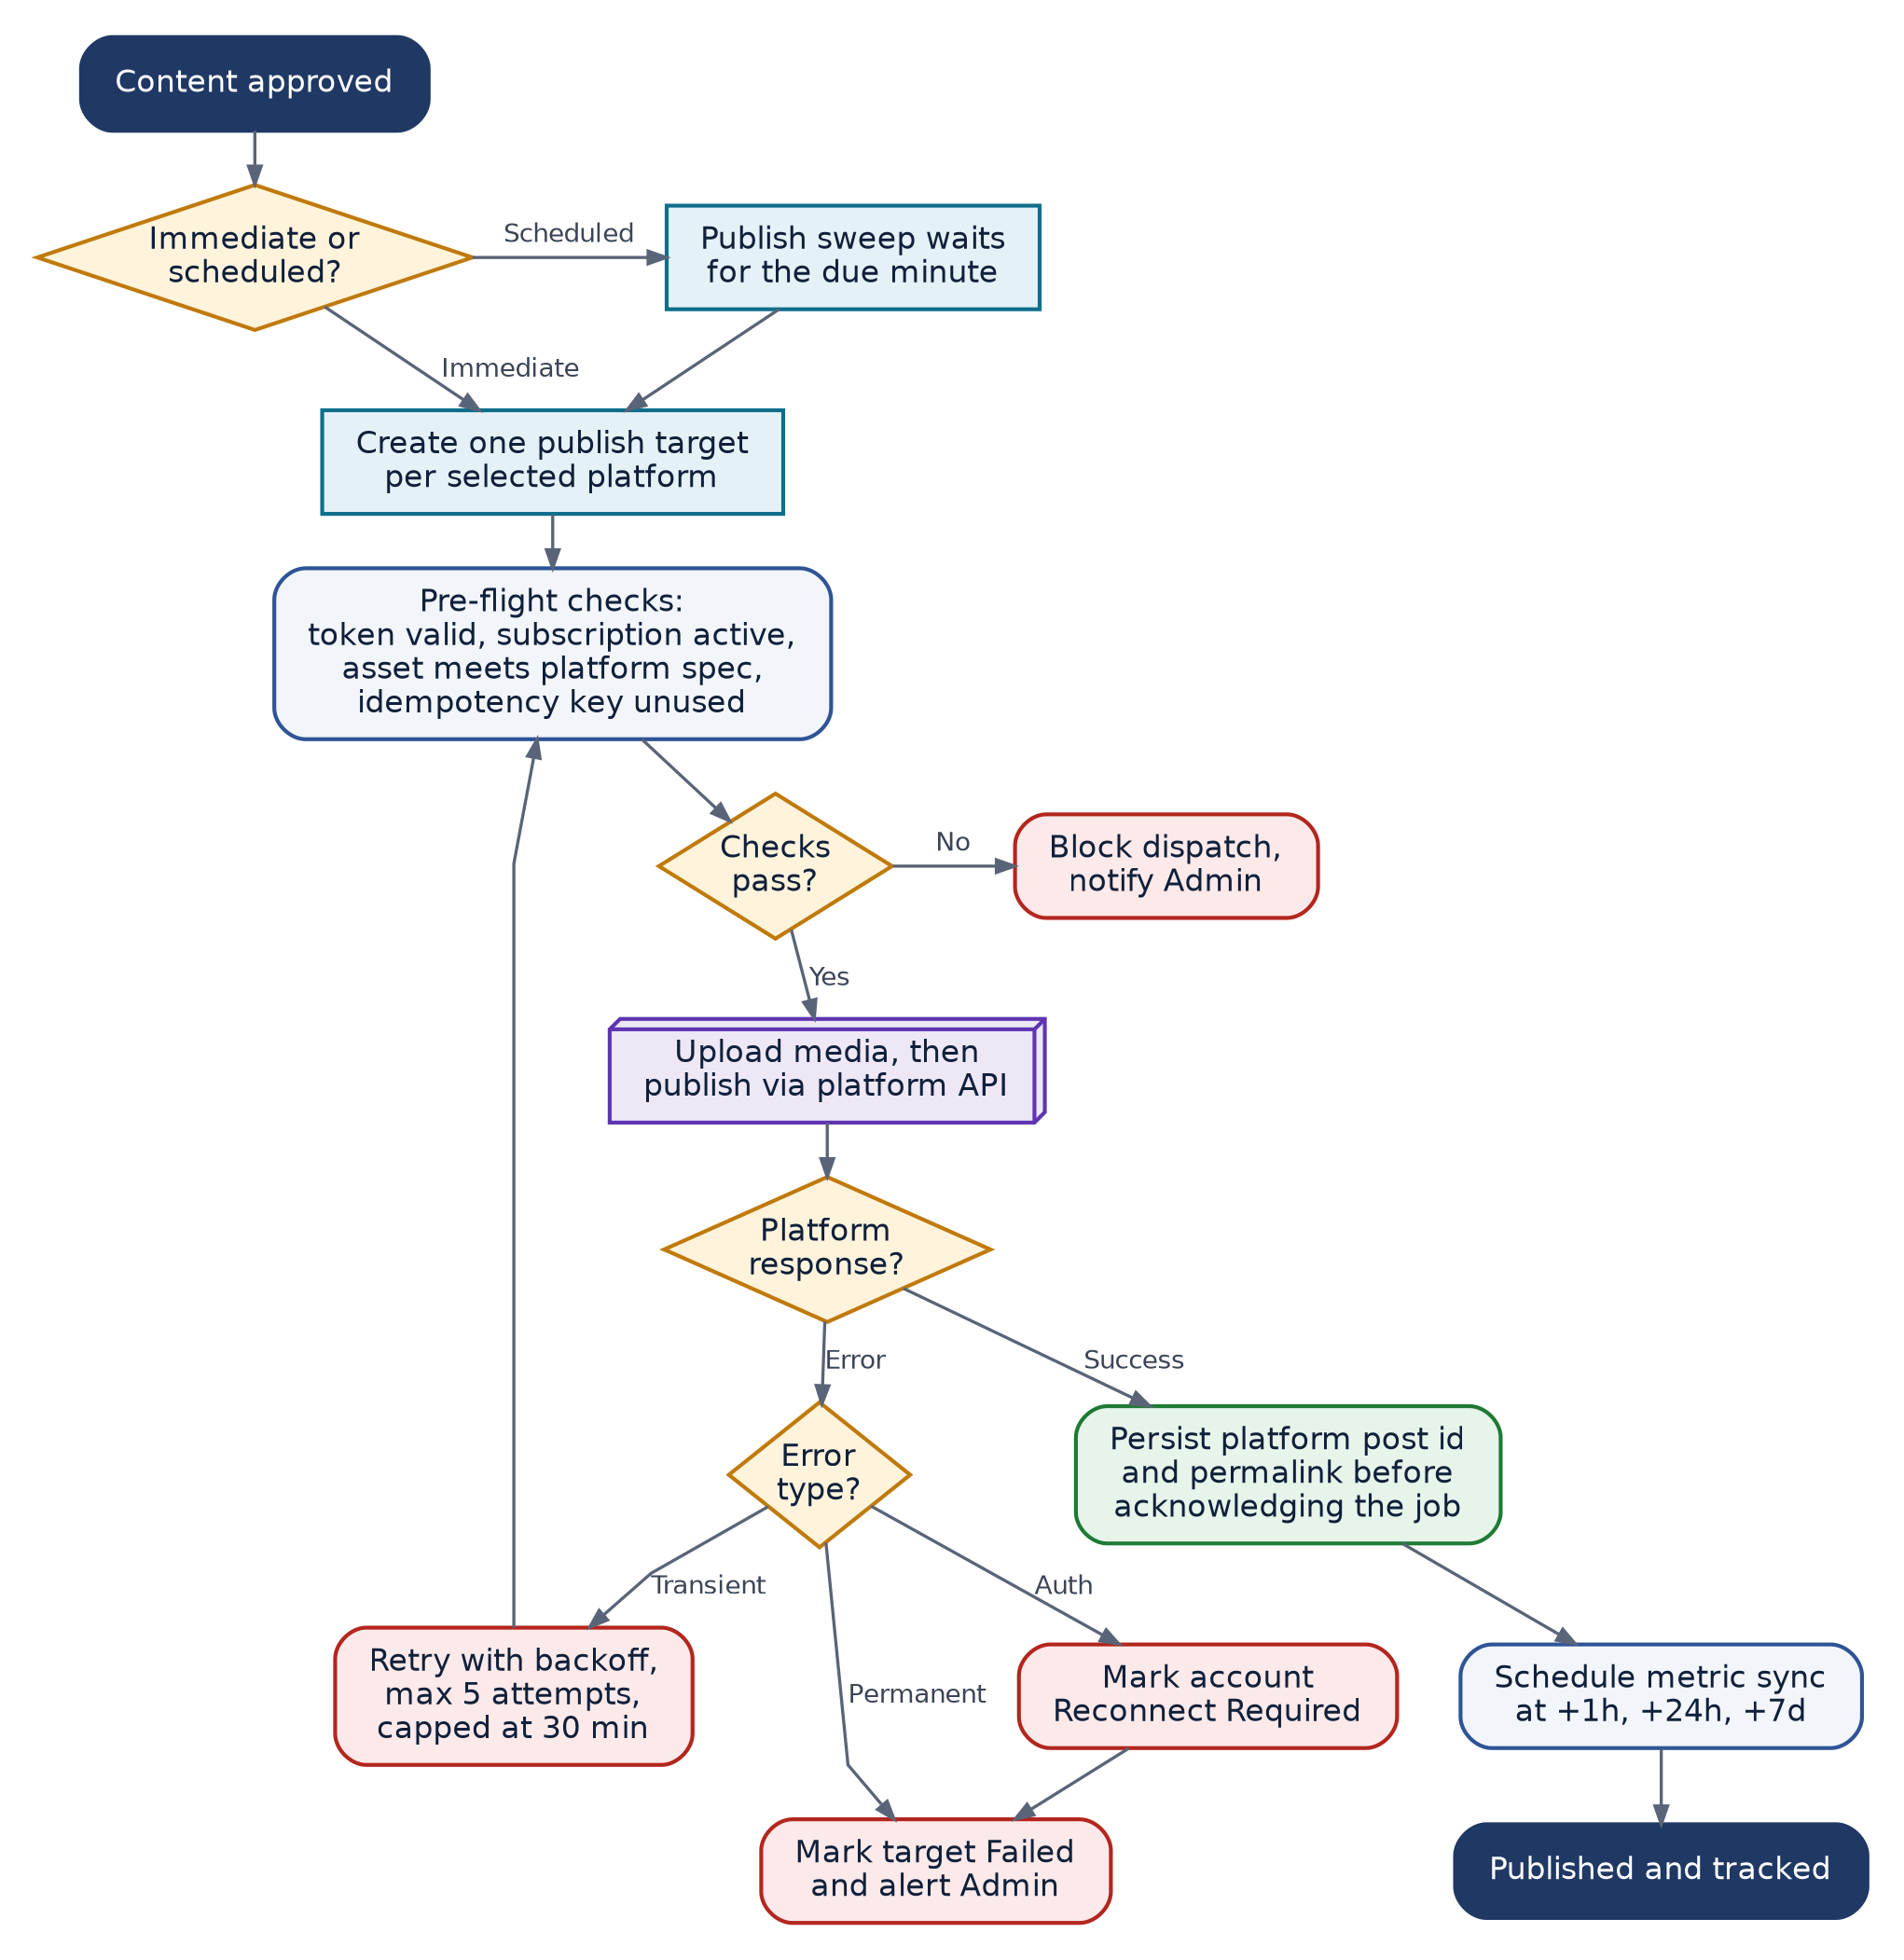
Figure F-08 — Publishing Flow with Retry Handling

F-09 Social Account Connection and Token Lifecycle
Traces to: FR-SOC-001 to FR-SOC-003, FR-SOC-006 · SDD §5.10, §10.3
OAuth connection and the ongoing hourly token health check. A token that cannot be refreshed marks the account Reconnect Required and blocks publishing rather than posting with a dead token.
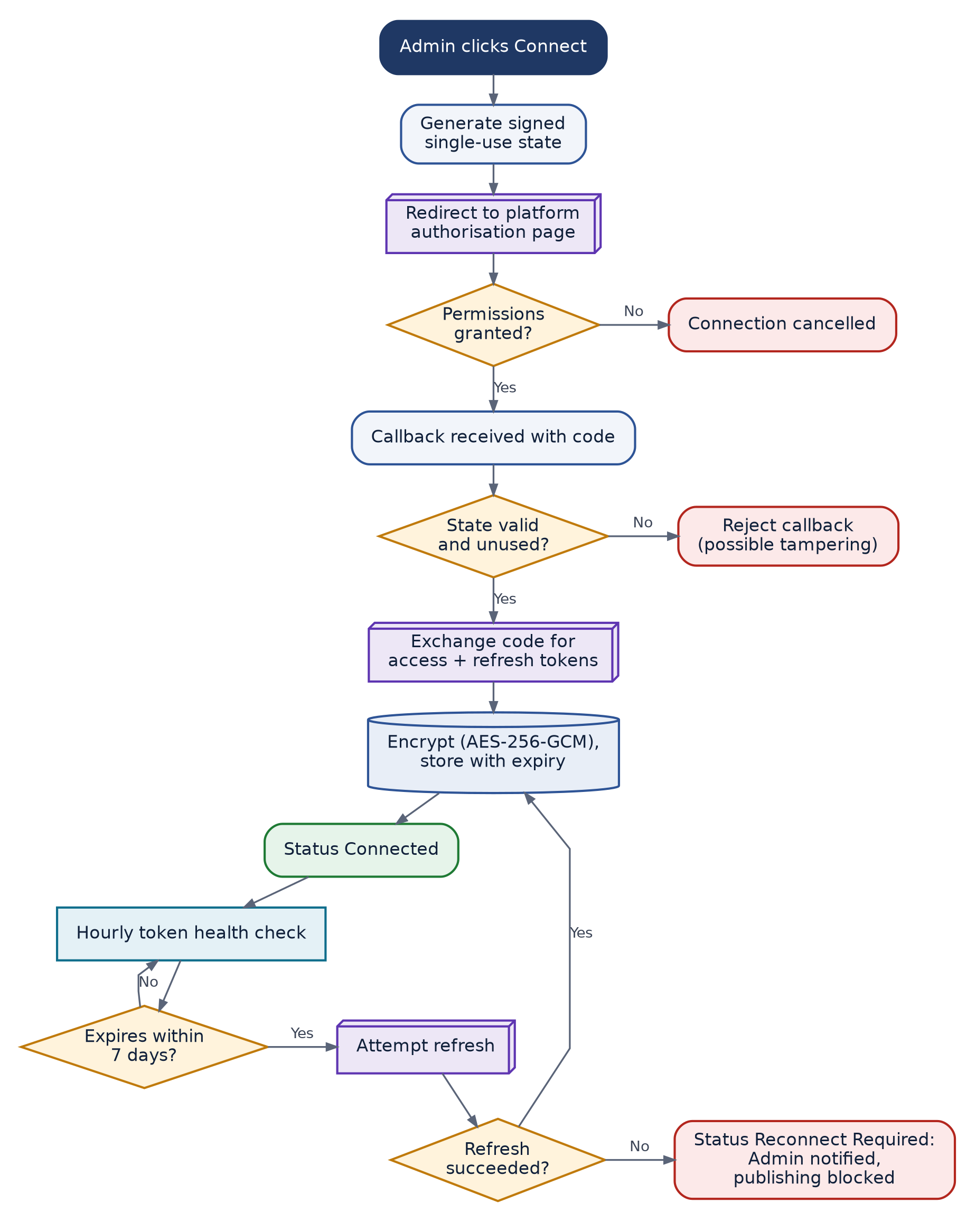
Figure F-09 — Social Account Connection and Token Lifecycle

F-10 Notification Dispatch Flow
Traces to: FR-NOT-001 to FR-NOT-005, FR-WA-003 to FR-WA-008 · SDD §5.11, §5.12
One event fans out to the channels the recipient has enabled. Repeated WhatsApp failure disables that channel for the company and falls back to email.
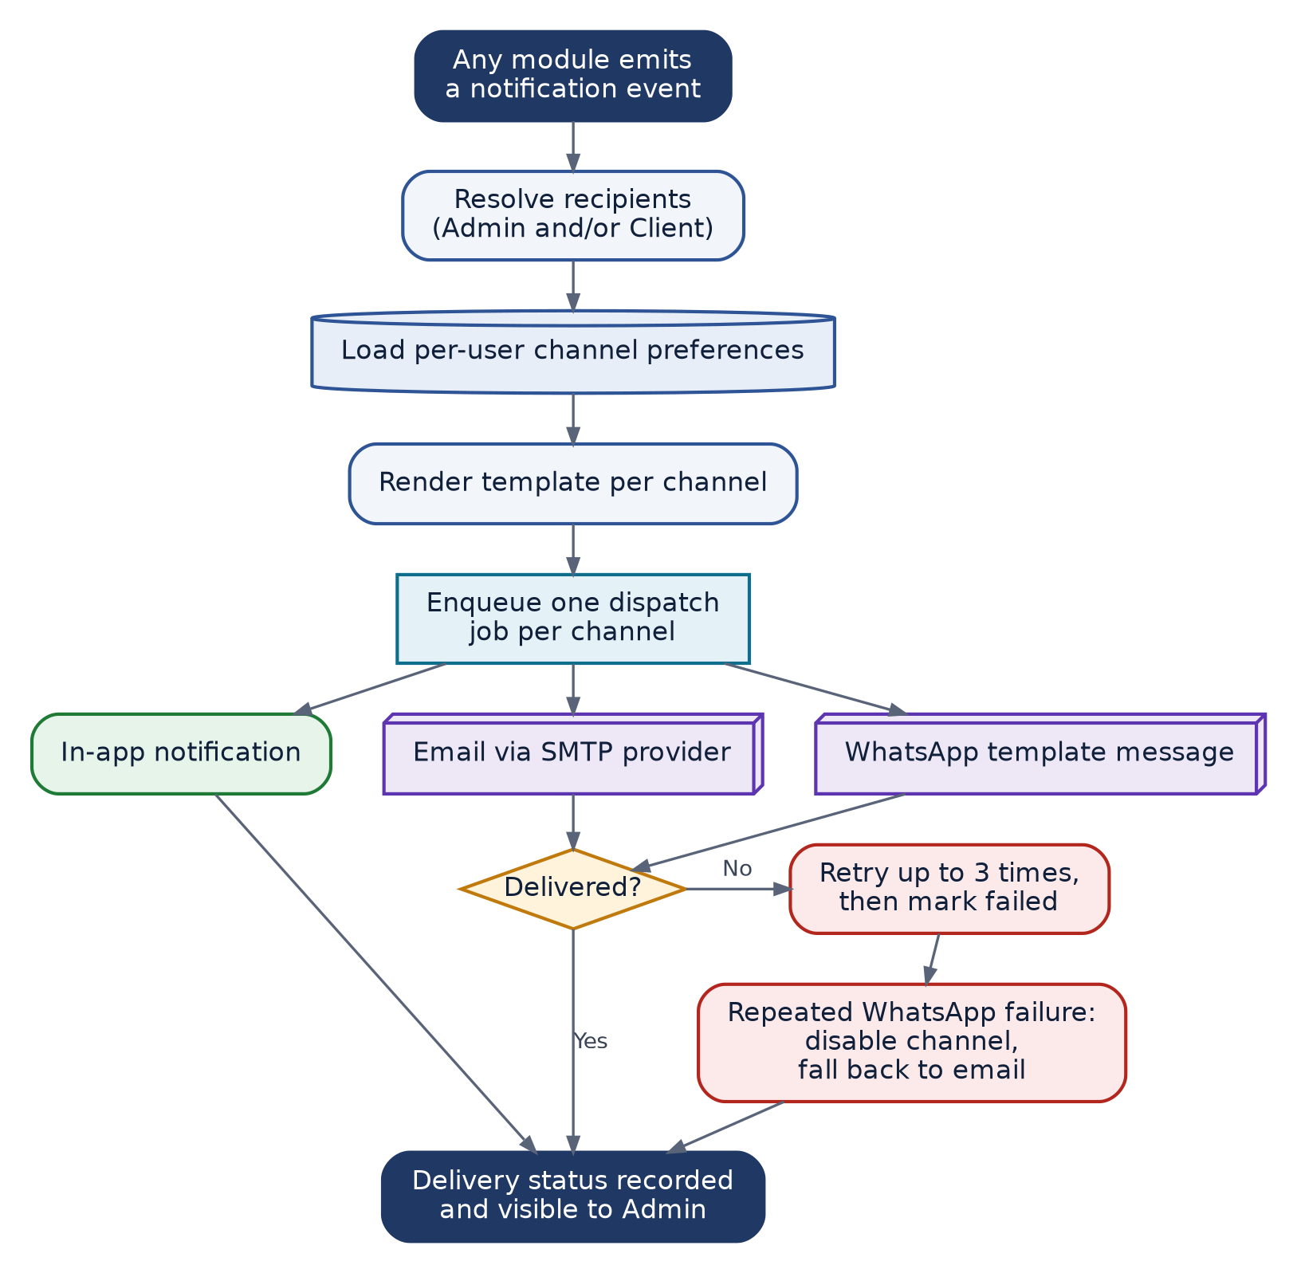
Figure F-10 — Notification Dispatch Flow

F-11 Analytics Collection and Reporting Flow
Traces to: SRS §10.6, FR-ANL-001 to FR-ANL-007, FR-REP-001 to FR-REP-005 · SDD §5.13, §5.14
Scheduled metric collection feeding dashboards, and the monthly report build. Metrics are stored as snapshots so history is preserved and growth can be charted.
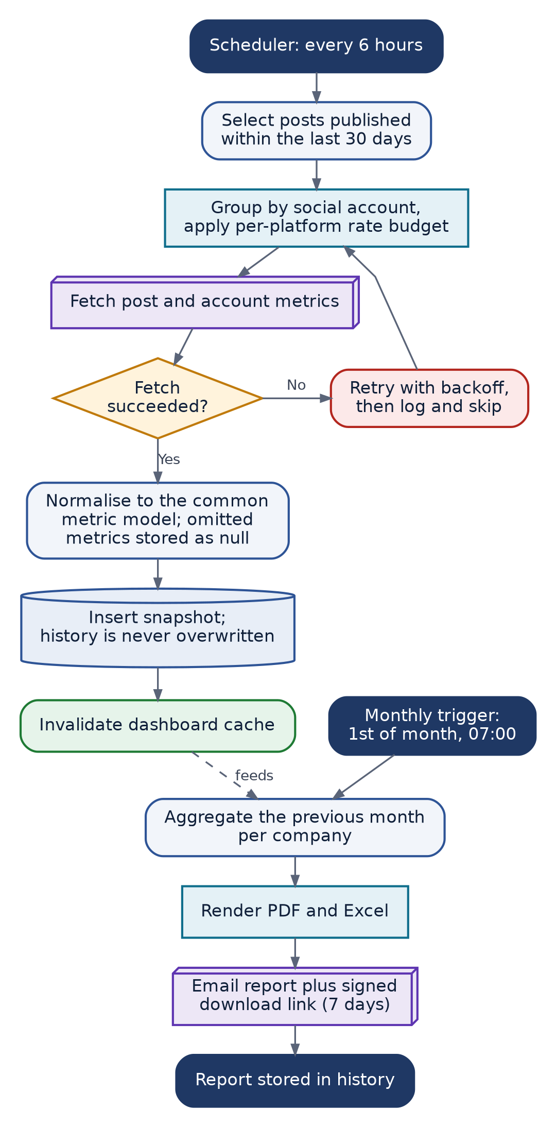
Figure F-11 — Analytics Collection and Reporting Flow

F-12 Subscription Lifecycle (State Diagram)
Traces to: SRS §26 · SDD §5.15
All subscription states and the transitions between them. Every transition is performed by the Admin; the platform never sells or processes payment.
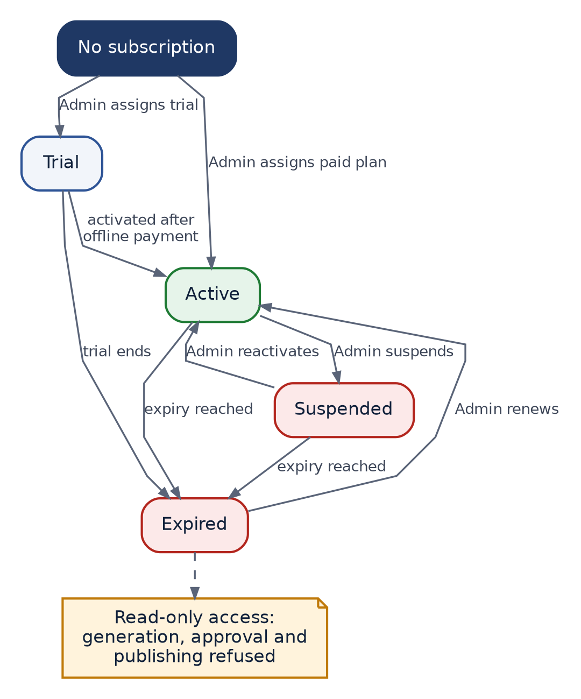
Figure F-12 — Subscription Lifecycle (State Diagram)

F-13 Content Item State Diagram
Traces to: SDD §5.5, §5.8, §5.9
The complete lifecycle of a single calendar item. Any transition not drawn here is illegal and must be rejected by the application.
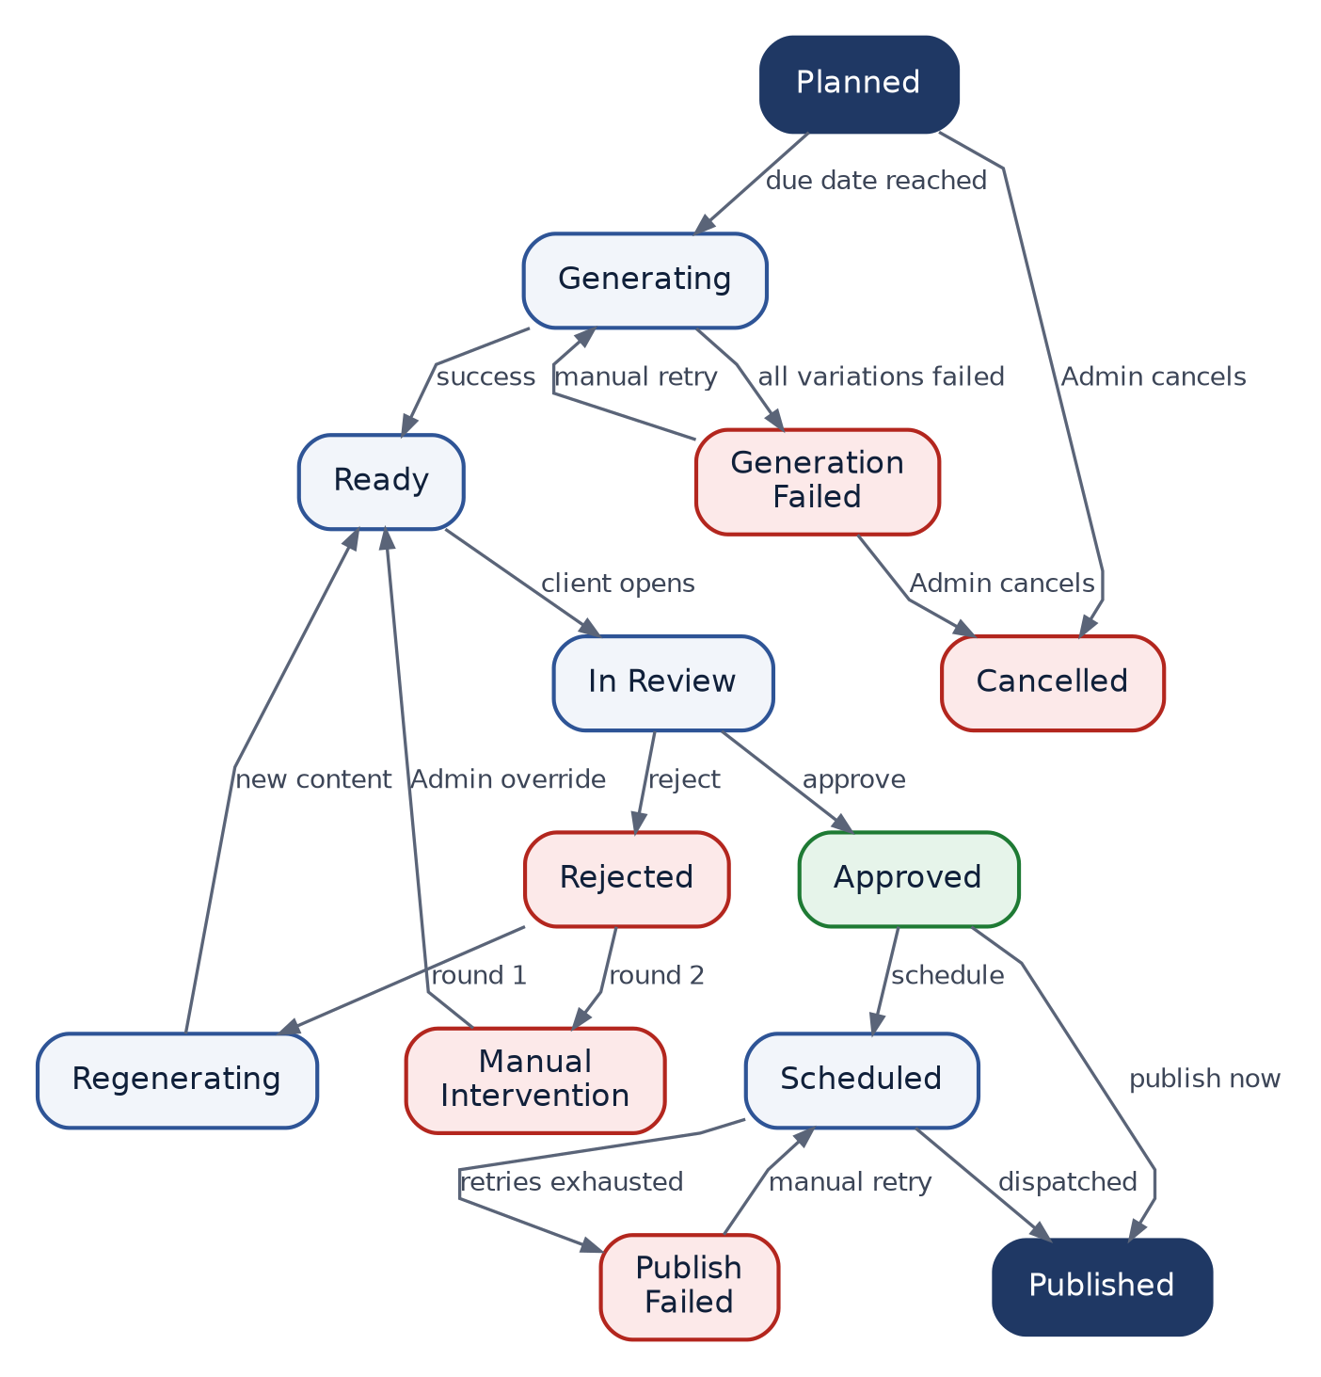
Figure F-13 — Content Item State Diagram

